IRB SYNOPSIS OF PROPOSAL

Every application submitted for review and approval shall have attached to it a page organized in numerical brief paragraph form as outlined below.

Barriers that affect college students who have reading difficulties

- The source of the potential subjects will be college students at Northwest Vista College in San Antonio, Texas who are enrolled in the 0302 developmental reading classes for the Fall 2008 semester. The students will be 18 years of age or older. The anticipated number of participants is approximately 140 students based on the total population of students enrolled in the 0302 level. The group will be chosen randomly including all ethnic groups: Hispanic, White, Asian, and African American. All participants are expected to be of sound mind and body. The data will come from the Department of Records and Admissions at Northwest Vista College. Criteria for inclusion in the study is that the participants must be enrolled in the Reading 0302 classes at Northwest Vista College.

- The participants will be randomly selected by computer. The researcher will contact the students via email asking for their participation on a voluntary basis. Upon receiving the email responses, the researcher will have each student who is willing to participate in the study, an informed consent form stating the title of the research study, any risks involved to them, any benefits, contact information, purpose of the study, any cost involved to the participants, any compensation, an opt out portion, and how the confidentiality of the participants will be kept.

- The method for the proposed study is a 20 question document to be filled out in person on the college campus. The questionnaire will be collected and kept secure until the researcher compiles the data and writes the recommendations and conclusions of the study. The questionnaire that will be used will consist of questions about the students’ interests in reading, how he/she sees himself as a reader, what motivates the students to read, etc. The students will circle the answer to the questions using a scale such as always, sometimes, often, never.

- The proposed research study poses no or minimal risk to all participants.

- There will be no need for medical treatment pertaining to the study, but any student may become ill at any time, so the researcher will call the nurse on duty at the Northwest Vista College campus. For confidentiality, the only time a student’s name will be used is in the consent form. The researcher has access to the students names and social security numbers because the students at Northwest Vista College are in the system according to their social security numbers. However, once the students are selected randomly, the papers with their sensitive material will be shredded. From the moment of survey collection to the time when the researcher compiles the data and writes the recommendations and conclusions, the questionnaires will be kept in the administrative office in a locked cabinet.

- The benefits to be gained as a result of this study are to help educators understand and identify barriers that developmental reading students encounter so that reading programs may be improved. There is no direct benefit to each participant except knowledge that he or she will be part of a very important study to improve educational needs.

- There will be no compensation for participating in the research study.

- There should not be any risks involved to the participants or society as a whole.

- The director of the Reading program at Northwest Vista College, Cindi Bluhm, signed a consent form for the researcher. The site that will be used in the study is Northwest Vista College in San Antonio, Texas. The address is 3535 N. Ellison Drive San Antonio, Texas 78251.

- The proposed activity is related to the researcher’s field of work because the researcher is an adjunct faculty member who teaches Reading at Northwest Vista College. The researcher is working towards the Masters Degree in hope of becoming a full time faculty member or a director of the Reading lab at Northwest Vista College. The supervising faculty member is Caroline Kuyumcuoglu. Her telephone number is 210-348-2272.

- In the case of student projects, pilot studies, theses, or dissertations, evidence of approval of Supervising Professor or Faculty Sponsor should be included. Thesis and dissertation proposals must be approved by the student’s committee before proceeding to the IRB for review.

- If the proposed study has been approved by another IRB, attach a copy of the letter verifying approval/disapproval and any related correspondence. If the proposed study has not been reviewed/approved by another IRB, please state this explicitly.

- The individuals who will have access to the results of the study are the researcher, the instructor of the OCED 5301 class, Dr. Michael Pierson, Caroline Kuyumcuoglu and possibly Kim Pendergraft who is the lab instructor at Texas State University and is available to assist if the researcher needs help with SPSS software.

In addition to this synopsis, you are required to submit all relevant documentation for review. This may include, but is not necessarily limited to: 1) recruiting documents (e.g., flyers, letter, e-mails, brochures, etc.), 2) a consent form, 3) an assent form, 4) letters of approval from relevant organization(s), 5) surveys/instruments/questionnaires, esp. those created by the researcher, 6) a list of questions that the researcher may ask (e.g., focus groups questions, questions for qualitative studies, etc.), and 7) all documents in translated versions.

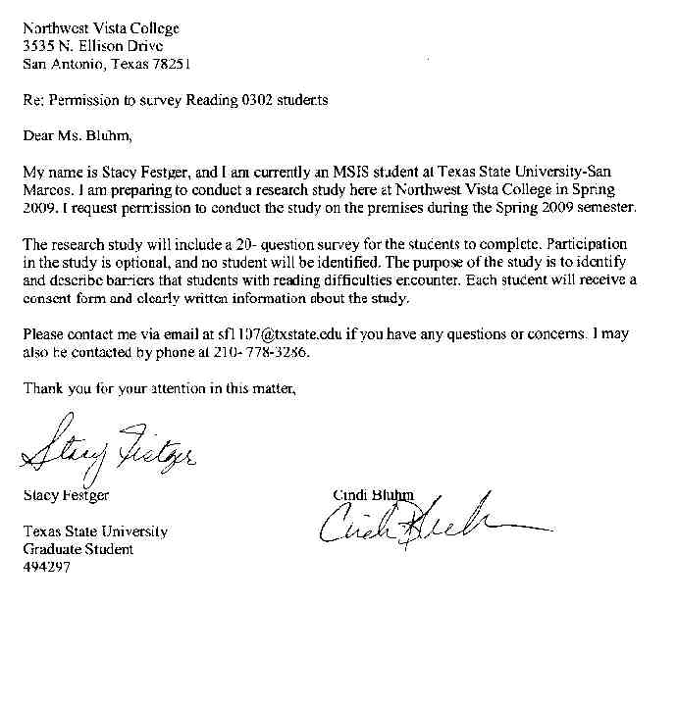

Instrument

F i g u r e 1
Ad o l e s c e n t Mo t i v a t i o n t o R e a d P r o f i l e r e a d i n g s u r v e y
Name: _________________________________________________ Date: _________________________
Sample 1: I am in ______________.
❑ Sixth grade
❑ Seventh grade
❑ Eighth grade
❑ Ninth grade
❑ Tenth grade
❑ Eleventh grade
❑ Twelfth grade

Sample 2: I am a ______________.
❑ Female
❑ Male

Sample 3: My race/ethnicity is ______________.
❑ African-American
❑ Asian/Asian American
❑ Caucasian
❑ Hispanic
❑ Native American
❑ Multi-racial/Multi-ethnic
❑ Other: Please specify ______________

1. My friends think I am ______________.
❑ a very good reader
❑ a good reader
❑ an OK reader
❑ a poor reader

2. Reading a book is something I like to do.
❑ Never
❑ Not very often
❑ Sometimes
❑ Often

3. I read ______________.
❑ not as well as my friends
❑ about the same as my friends
❑ a little better than my friends
❑ a lot better than my friends

4. My best friends think reading is ______________.
❑ really fun
❑ fun
❑ OK to do
❑ no fun at all

5. When I come to a word I don’t know, I can
______________.
❑ almost always figure it out
❑ sometimes figure it out
❑ almost never figure it out
❑ never figure it out

6. I tell my friends about good books I read.
❑ I never do this
❑ I almost never do this
❑ I do this some of the time
❑ I do this a lot

7. When I am reading by myself, I understand
______________.
❑ almost everything I read
❑ some of what I read
❑ almost none of what I read
❑ none of what I read

8. People who read a lot are ______________.
❑ very interesting
❑ interesting
❑ not very interesting
❑ boring

9. I am ______________.
❑ a poor reader
❑ an OK reader
❑ a good reader
❑ a very good reader (continued)

10. I think libraries are ______________.
❑ a great place to spend time
❑ an interesting place to spend time
❑ an OK place to spend time
❑ a boring place to spend time

11. I worry about what other kids think about
my reading ______________.
❑ every day
❑ almost every day
❑ once in a while
❑ never

12. Knowing how to read well is ______________.
❑ not very important
❑ sort of important
❑ important
❑ very important

13. When my teacher asks me a question about
what I have read, I ______________.
❑ can never think of an answer
❑ have trouble thinking of an answer
❑ sometimes think of an answer
❑ always think of an answer

14. I think reading is ______________.
❑ a boring way to spend time
❑ an OK way to spend time
❑ an interesting way to spend time
❑ a great way to spend time

15. Reading is ______________.
❑ very easy for me
❑ kind of easy for me
❑ kind of hard for me
❑ very hard for me

16. As an adult, I will spend ______________.
❑ none of my time reading
❑ very little time reading
❑ some of my time reading
❑ a lot of my time reading

17. When I am in a group talking about what we are
reading, I ______________.
❑ almost never talk about my ideas
❑ sometimes talk about my ideas
❑ almost always talk about my ideas
❑ always talk about my ideas

18. I would like for my teachers to read out loud in
my classes ______________.
❑ every day
❑ almost every day
❑ once in a while
❑ never

19. When I read out loud I am a ______________.
❑ poor reader
❑ OK reader
❑ good reader
❑ very good reader

20. When someone gives me a book for a present, I
feel ______________.
❑ very happy
❑ sort of happy
❑ sort of unhappy
❑ unhappy

IRB#_____________

Informed Consent to Participate in Research

Texas State University at San Marcos

You are being asked to participate in a research study. This form provides you with information about the study. The Principal Investigator, (your name), or his representative Dr. Stephen Springer can describe this study to you and answer all of your questions. Please read the information below and ask questions about anything you don’t understand before deciding whether or not to take part. Your participation is entirely voluntary and you can refuse to participate without penalty or loss of benefits to which you are otherwise entitled. If you wish you may keep a copy of this consent form.

Title of Research Study:

Principal Investigators and Telephone Numbers:

Funding source:
Personal funds will be utilized. No compensation will be given to the survey participants.

What is the purpose of this study?

What will be done if you take part in this research study?
Example- a survey will be administered. It is strictly voluntary, as well as confidential. At no point will the completed survey be tied to the signed consent form.

What are the possible discomforts and risks?
Example-the primary risk to participants is the discomfort that can occur from being tested. We will do everything that we can to minimize this discomfort and to put you at ease. You may decline to answer any question(s) and you can choose to discontinue answering the survey at any time.
If you wish to discuss the information above or any other risks you may experience, you may call the Principal Investigator listed on the front page of this form.

Your employment will not be affected in any way due to your participation.

What are the possible benefits to you or to others?
Example-results from the study will be measured and conclusions drawn. Following this, suggestions to management will be given based on the conclusions.

If you choose to take part in this study, will it cost you anything?
There are no costs associated with participating in this study.

Will you receive compensation for your participation in this study?

There is no compensation for participating in this study.

What if you are injured because of the study?
This study does not involve physical risk and no injuries are anticipated; however, no treatment will be provided for research related injury and no payment can be provided in the event of a medical problem.

If you do not want to take part in this study, what other options are available to you?
Participation in this study is entirely voluntary. You are free to refuse to be in the study, and your refusal will not influence employment.

How can you withdraw from this research study?
If you wish to stop your participation in this research study for any reason, you should contact: J(your name) at (phone number) or at (your email). You are free to withdraw your consent and stop participation in this research study at any time without penalty. Throughout the study, the researchers will notify you of new information that may become available and that might affect your decision to remain in the study.

In addition, if you have questions about your rights as a research participant, please contact Dr. Springer, Occupational Education, (512) 245-2115.

How will your privacy and the confidentiality of your research records be protected?
If the results of this research are published or presented at scientific meetings, your identity will not be disclosed.

Authorized persons from the Institutional Review Board have the legal right to review research records and will protect the confidentiality of those records to the extent permitted by law. If the research project is sponsored then the sponsors also have the legal right to review your research records. Otherwise, your research records will not be released without your consent unless required by law or a court order.

Will the researchers benefit from your participation in this study?
There is no benefit to researchers participating in this study beyond publishing or presenting the results.

Signatures:
You have been informed about this study’s purpose, procedures, possible benefits and risks, and you have received a copy of this Form. You have been given the opportunity to ask questions before you sign, and you have been told that you can ask other questions at any time. You voluntarily agree to participate in this study. By signing this form, you are not waiving any of your legal rights.

___________________________________________________________________
Printed Name of Participant Date

___________________________________________________________________
Signature of Participant Date

___________________________________________________________________
Signature of Principal Investigator Date

